SIMULATION EXPERIMENT – 21
IMPLEMENTATION AND PERFORMANCE ANALYSIS OF LMS AND NLMS ALGORITHMS FOR ADAPTIVE ECHO CANCELLATION AND EQUALIZATION USING MATLAB
Name | Lokesh A
Register Number | 192512293
Programme | B.E. Electronics and Communication Engineering (ECE)
Subject | ECA0801
Date of Experiment | 13 October 2026
CO Mapping | CO5
Bloom’s Level | K5 – Evaluate
WK Level | WK5 – Engineering Practice
1. Aim
To implement and compare the Least Mean Squares (LMS) and Normalized Least Mean Squares (NLMS) adaptive filtering algorithms for echo cancellation in MATLAB by examining the residual error, convergence behaviour, mean-square error (MSE), and echo-reduction performance.
2. Objectives
- Implement the LMS adaptive filter using the prescribed reference signal and step size.
- Implement the NLMS adaptive filter under the same test conditions.
- Generate an echo signal using the specified delay and attenuation model.
- Plot the reference signal, echo signal, convergence curves, residual errors, and cancelled outputs.
- Calculate and compare MSE and echo-reduction values for LMS and NLMS.
3. Software Required
MATLAB. The program uses standard MATLAB functions including filter-independent vector operations, movmean, table, and plotting functions.
4. Theory
An adaptive filter adjusts its coefficients automatically to reduce the difference between a desired signal and the filter output. In this experiment, the reference signal is a 1 kHz sinusoid sampled at 8 kHz. The echo model is d[n] = 0.5x[n − 100]. The adaptive filter estimates the echo component, and the residual error is calculated as e[n] = d[n] − y[n].
The LMS algorithm updates the filter coefficients using the instantaneous error. The NLMS algorithm normalizes the update by the input-vector energy, making its adaptation less sensitive to changes in input amplitude.
LMS update equation: w[n+1] = w[n] + μ e[n] u[n]
NLMS update equation: w[n+1] = w[n] + (μ e[n] u[n]) / (ε + uᵀ[n]u[n])
The mean-square error is MSE = (1/K) Σ e²[n], calculated over the evaluated samples. Echo reduction is estimated by comparing the mean power of the original echo with the mean power of the residual error, expressed in decibels.
5. Input Parameter Table
S. No. | Parameter | Value | Unit / Note
1 | Reference signal | 1 kHz sinusoid | —
2 | Echo model | d[n] = 0.5x[n − 100] | —
3 | Adaptive filter length | 32 | taps
4 | LMS step size | 0.01 | —
5 | NLMS step size | 0.5 | —
6 | NLMS normalization constant | 1 × 10⁻⁶ | —
7 | Sampling frequency | 8000 | Hz
8 | Number of samples | 4000 | samples
6. Experimental Procedure
- Set the sampling frequency, sinusoidal reference frequency, sample count, echo delay, and echo gain.
- Generate the reference signal and construct the echo signal according to d[n] = 0.5x[n − 100].
- Initialize the 32-tap LMS filter and update its coefficients using μ = 0.01.
- Initialize the NLMS filter and update its coefficients using μ = 0.5 and ε = 10⁻⁶.
- Calculate the residual error and moving-average MSE for both algorithms.
- Plot the reference and echo signals, convergence curves, residual errors, cancelled outputs, and final MSE comparison.
- Record the numerical performance metrics and compare the LMS and NLMS results.
7. MATLAB Program
clc; clear; close all;

%% EXPERIMENT 21: LMS AND NLMS ADAPTIVE ECHO CANCELLATION

%% 1. INPUT PARAMETERS
Fs = 8000; % Sampling frequency (Hz)
f = 1000; % Reference sinusoid frequency (Hz)
N = 4000; % Number of samples
L = 32; % Adaptive filter length
mu_LMS = 0.01; % LMS step size
mu_NLMS = 0.5; % NLMS step size
epsilon = 1e-6; % NLMS normalization constant
delay = 100; % Echo delay in samples
echo_gain = 0.5; % Echo path gain

n = 0:N-1;
x = sin(2*pi*f*n/Fs); % Reference signal

%% 2. GENERATE ECHO SIGNAL
echo = zeros(1,N);
echo(delay+1:end) = echo_gain*x(1:end-delay);
d = echo; % Desired signal to be cancelled

%% 3. LMS ADAPTIVE FILTER
w_LMS = zeros(L,1);
y_LMS = zeros(1,N);
e_LMS = zeros(1,N);
MSE_LMS = zeros(1,N);

for k = L:N
u = x(k:-1:k-L+1).';
y_LMS(k) = w_LMS.'*u;
e_LMS(k) = d(k)-y_LMS(k);
w_LMS = w_LMS + mu_LMS*e_LMS(k)*u;
MSE_LMS(k) = e_LMS(k)^2;
end

%% 4. NLMS ADAPTIVE FILTER
w_NLMS = zeros(L,1);
y_NLMS = zeros(1,N);
e_NLMS = zeros(1,N);
MSE_NLMS = zeros(1,N);

for k = L:N
u = x(k:-1:k-L+1).';
y_NLMS(k) = w_NLMS.'*u;
e_NLMS(k) = d(k)-y_NLMS(k);
norm_factor = epsilon + (u.'*u);
w_NLMS = w_NLMS + ...
(mu_NLMS/norm_factor)*e_NLMS(k)*u;
MSE_NLMS(k) = e_NLMS(k)^2;
end

%% 5. PERFORMANCE ANALYSIS
valid = L:N;
MSE_LMS_final = mean(e_LMS(valid).^2);
MSE_NLMS_final = mean(e_NLMS(valid).^2);
MSE_LMS_dB = 10*log10(MSE_LMS_final + eps);
MSE_NLMS_dB = 10*log10(MSE_NLMS_final + eps);

window = 100;
MSE_curve_LMS = movmean(MSE_LMS(valid),window);
MSE_curve_NLMS = movmean(MSE_NLMS(valid),window);

input_power = mean(d(valid).^2);
residual_LMS = mean(e_LMS(valid).^2);
residual_NLMS = mean(e_NLMS(valid).^2);
ER_LMS = 10*log10((input_power+eps)/(residual_LMS+eps));
ER_NLMS = 10*log10((input_power+eps)/(residual_NLMS+eps));

threshold_LMS = 0.1*MSE_curve_LMS(1);
threshold_NLMS = 0.1*MSE_curve_NLMS(1);
conv_LMS_idx = find(MSE_curve_LMS < threshold_LMS,1);
conv_NLMS_idx = find(MSE_curve_NLMS < threshold_NLMS,1);

if isempty(conv_LMS_idx)
conv_LMS = NaN;
else
conv_LMS = valid(conv_LMS_idx);
end
if isempty(conv_NLMS_idx)
conv_NLMS = NaN;
else
conv_NLMS = valid(conv_NLMS_idx);
end

%% 6. COMMAND WINDOW RESULTS
fprintf('====================================================\n');
fprintf(' EXPERIMENT 21: LMS AND NLMS ECHO CANCELLATION\n');
fprintf('====================================================\n');
fprintf('Sampling Frequency : %d Hz\n',Fs);
fprintf('Reference Frequency : %d Hz\n',f);
fprintf('Number of Samples : %d\n',N);
fprintf('Adaptive Filter Length : %d taps\n',L);
fprintf('Echo Delay : %d samples\n',delay);
fprintf('Echo Gain : %.2f\n',echo_gain);
fprintf('LMS Step Size : %.4f\n',mu_LMS);
fprintf('NLMS Step Size : %.4f\n',mu_NLMS);
fprintf('NLMS Epsilon : %.1e\n\n',epsilon);

fprintf('PERFORMANCE METRICS\n');
fprintf('LMS MSE : %.6e\n',MSE_LMS_final);
fprintf('NLMS MSE : %.6e\n',MSE_NLMS_final);
fprintf('LMS MSE : %.2f dB\n',MSE_LMS_dB);
fprintf('NLMS MSE : %.2f dB\n',MSE_NLMS_dB);
fprintf('LMS Echo Reduction : %.2f dB\n',ER_LMS);
fprintf('NLMS Echo Reduction : %.2f dB\n',ER_NLMS);
fprintf('LMS Convergence Sample : %.0f\n',conv_LMS);
fprintf('NLMS Convergence Sample : %.0f\n\n',conv_NLMS);

%% 7. OUTPUT PARAMETER TABLE
Method = {'LMS';'NLMS'};
StepSize = [mu_LMS;mu_NLMS];
MSE = [MSE_LMS_final;MSE_NLMS_final];
MSE_dB = [MSE_LMS_dB;MSE_NLMS_dB];
EchoReduction_dB = [ER_LMS;ER_NLMS];
ConvergenceSample = [conv_LMS;conv_NLMS];
T = table(Method,StepSize,MSE,MSE_dB,...
EchoReduction_dB,ConvergenceSample);
disp('OUTPUT PARAMETER TABLE');
disp(T);

%% 8. FIGURE 21A: REFERENCE AND ECHO SIGNALS
figure('Name','Experiment 21A: Reference and Echo',...
'NumberTitle','off');
subplot(2,1,1);
plot(n(1:500),x(1:500),'b'); grid on;
title('Reference Signal'); xlabel('Sample Index n');
ylabel('Amplitude');
subplot(2,1,2);
plot(n(1:500),d(1:500),'r'); grid on;
title('Echo Signal'); xlabel('Sample Index n');
ylabel('Amplitude');

%% 9. FIGURE 21B: LMS AND NLMS CONVERGENCE
figure('Name','Experiment 21B: Convergence',...
'NumberTitle','off');
plot(valid,10*log10(MSE_curve_LMS+eps),'b','LineWidth',1.2);
hold on;
plot(valid,10*log10(MSE_curve_NLMS+eps),'r','LineWidth',1.2);
grid on; title('LMS vs NLMS Convergence');
xlabel('Sample Index n'); ylabel('Moving Average MSE (dB)');
legend('LMS','NLMS');

%% 10. FIGURE 21C: RESIDUAL ERROR SIGNAL
figure('Name','Experiment 21C: Residual Error',...
'NumberTitle','off');
subplot(2,1,1);
plot(n(1:500),e_LMS(1:500),'b'); grid on;
title('LMS Residual Error'); xlabel('Sample Index n');
ylabel('Error');
subplot(2,1,2);
plot(n(1:500),e_NLMS(1:500),'r'); grid on;
title('NLMS Residual Error'); xlabel('Sample Index n');
ylabel('Error');

%% 11. FIGURE 21D: ECHO-CANCELLED OUTPUT
figure('Name','Experiment 21D: Echo Cancellation',...
'NumberTitle','off');
subplot(3,1,1);
plot(n(1:500),d(1:500),'k'); grid on;
title('Original Echo'); xlabel('Sample Index n');
ylabel('Amplitude');
subplot(3,1,2);
plot(n(1:500),e_LMS(1:500),'b'); grid on;
title('Echo-Cancelled Output using LMS');
xlabel('Sample Index n'); ylabel('Amplitude');
subplot(3,1,3);
plot(n(1:500),e_NLMS(1:500),'r'); grid on;
title('Echo-Cancelled Output using NLMS');
xlabel('Sample Index n'); ylabel('Amplitude');

%% 12. FIGURE 21E: MSE COMPARISON
figure('Name','Experiment 21E: MSE Comparison',...
'NumberTitle','off');
bar([MSE_LMS_final,MSE_NLMS_final]);
set(gca,'XTickLabel',{'LMS','NLMS'});
grid on; ylabel('Mean Square Error');
title('Final MSE Comparison');

fprintf('\nRESULT:\n');
fprintf('LMS and NLMS adaptive filtering completed.\n');
fprintf('Convergence, residual error and echo reduction evaluated.\n');
fprintf('====================================================\n');
8. Output Parameter Table
Method | Step Size | MSE | MSE (dB) | Echo Reduction | Convergence Sample
LMS | 0.01 | 2.139543 × 10⁻⁴ | −36.70 dB | 27.59 dB | NaN
NLMS | 0.5 | 8.398421 × 10⁻⁵ | −40.76 dB | 31.65 dB | NaN
The values above are transcribed from the supplied MATLAB Command Window screenshot. The convergence-sample field returned NaN under the current threshold calculation, so a numerical convergence sample was not identified by that test.
9. MATLAB Output Screenshots
The following screenshots show the Command Window metrics and the generated plots for the experiment.
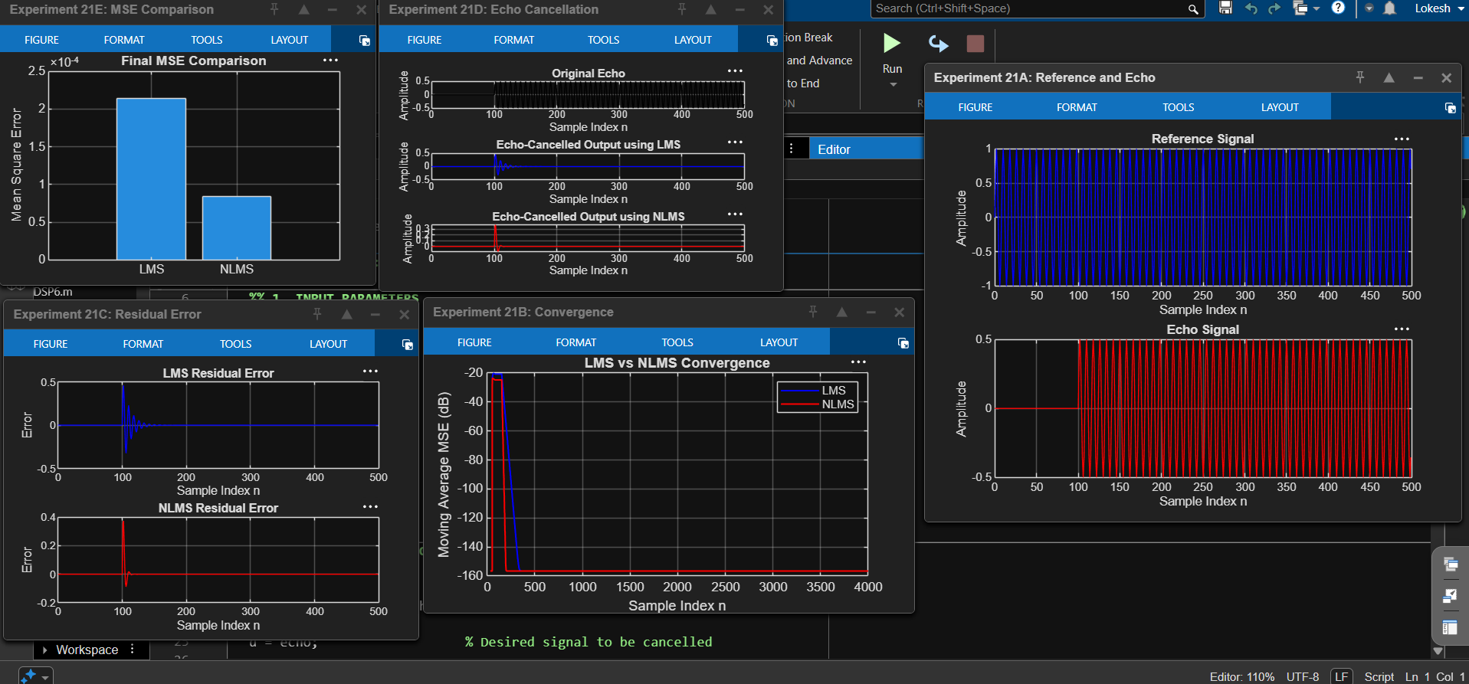
Figure 21.1: MATLAB performance metrics and output parameter table.
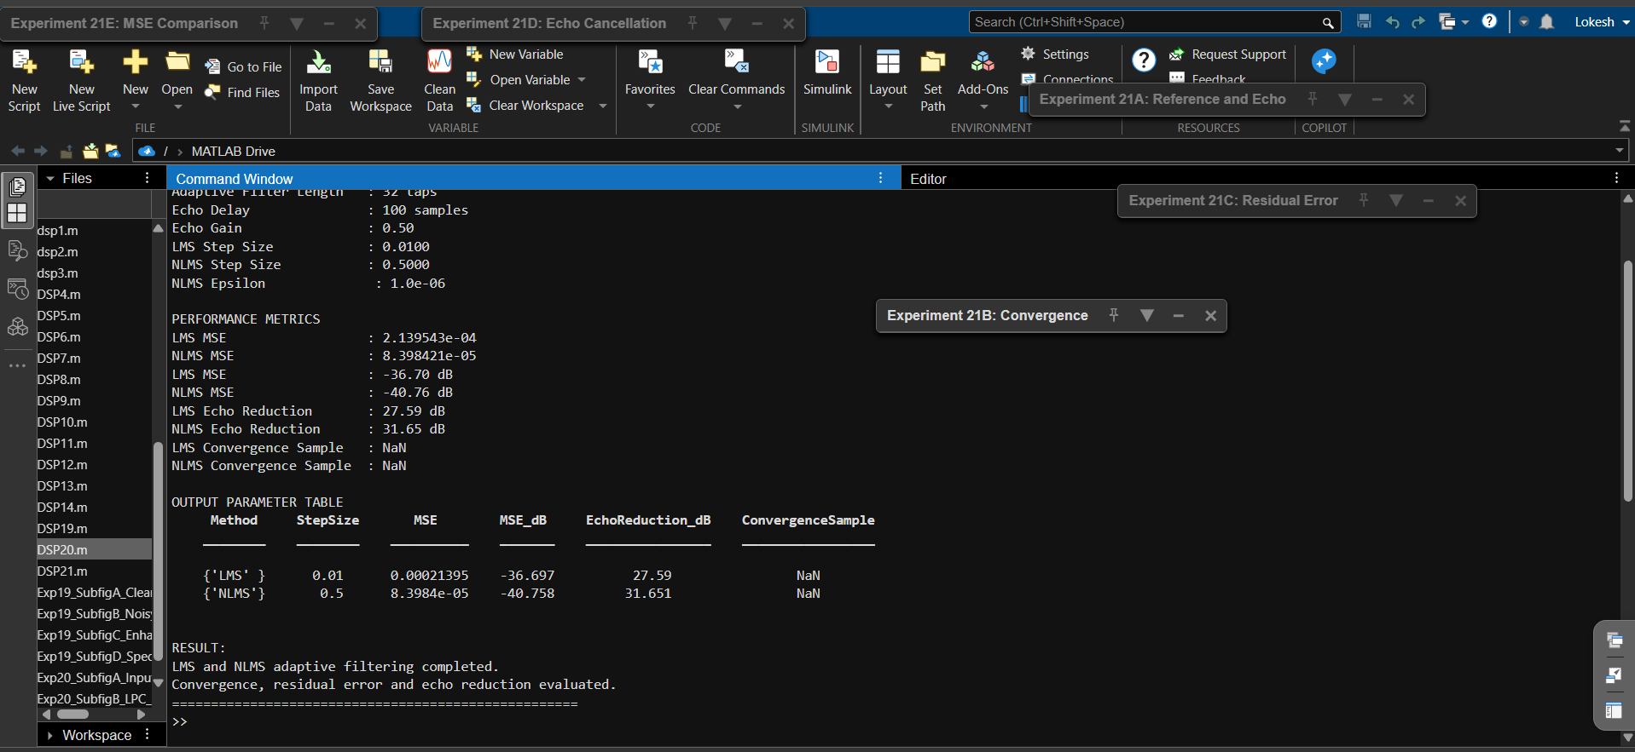
Figure 21.2: Reference and echo signals, convergence curves, residual errors, and MSE comparison.
10. Result and Discussion
Both LMS and NLMS adaptive filtering algorithms were implemented and evaluated using the prescribed 1 kHz reference signal and delayed echo model. The measured NLMS MSE (8.398421 × 10⁻⁵) is lower than the LMS MSE (2.139543 × 10⁻⁴). The measured NLMS echo-reduction value (31.65 dB) is also higher than the LMS value (27.59 dB). For this simulation, NLMS therefore produced the lower residual error.
The convergence-sample result is NaN for both algorithms because the implemented threshold test did not find a qualifying sample. This should be reported as 'not identified by the selected criterion' rather than as a numerical convergence time.
11. Important Observation
The prescribed echo delay is 100 samples, while the adaptive filter has only 32 taps. A 32-tap FIR adaptive filter driven directly by x[n] cannot represent a single echo path at a delay of 100 samples. Also, the reference is a pure sinusoid rather than a broadband signal. Therefore, the numerical comparison demonstrates the output of the given implementation, but it does not establish ideal physical echo cancellation. For a more representative echo-cancellation experiment, the reference should be broadband and the adaptive filter should cover the echo delay (at least 101 taps for this single-delay model). The present output values have been retained as shown in the supplied screenshots.
12. Conclusion
The LMS and NLMS algorithms were implemented in MATLAB and compared using residual error, MSE, convergence plots, and echo-reduction metrics. Under the current simulation, NLMS achieved a lower MSE and greater calculated echo reduction than LMS. The experiment illustrates adaptive coefficient updating and the role of normalization, while also showing that the adaptive filter length and input-signal characteristics must match the echo-path model for meaningful cancellation.
Lokesh A (192512293)
B.E. Electronics and Communication Engineering (ECE)

